C:\Users\ba.wolftv\AppData\Local\Microsoft\Windows\Temporary Internet Files\Content.IE5\9TK2FQ0R\MC900134551[1].wmf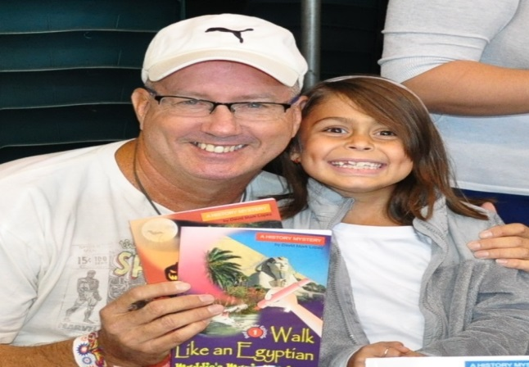

# iRead

# Tuesdays, 3:30-5:30 p.m.

Is your internet out at home? Does your computer run slowly? Don’t worry! Come to iRead! On Tuesdays, the Media Center keeps its doors open late for students and parents. Students can participate in making crafts, reading on the computer, playing games, and doing homework. Parents are welcome use the computers during this time. Children who attend must be accompanied by an adult.

* We are very proud of the students who participated in the Hat Trick (reading 3 nonfiction books and passing SRC quizzes on them). Students will receive their free Gwinnett Gladiator hockey ticket after the Christmas break. The game is on January 23rd, 2015.
* Scholastic Reading Counts (SRC) is going very well! Students are doing a great job of taking quizzes and earning points and prizes. See the site below for more information.  
    
  <http://src.scholastic.com>
* Students have also been using IStation to discover their Lexile level.

[www.istation.com](http://www.istation.com)

[www.lexile.com](http://www.lexile.com)

# Other News

We had an AWESOME author visit on November 7th! Students were able to meet and greet the author of the *Maddie’s Magic Marker* series, David Mark Lopez. Many students and teachers bought his books and are giving us very positive reviews. Visit his website below for more information.  
<http://www.davidmarklopez.com>

# Author Visit

Congratulations to these students for reading one million words this year!

1. Noah Johnson- 4th grade  
2. Abe Gonzalez- 5th grade  
3. Conner Johnston- 5th grade  
4. Andrew Mixon- 4th grade  
5. Sean Bailey- 5th grade  
6. Juan Borrego- 5th grade  
7. Reece Pomerantz- 4th grade  
8. Trey Kazienko- 5th grade  
9. Nicolas Keller- 4th grade  
10. Marco Borrego- 5th grade  
11. Maya Joshi- 4th grade

# Million Word Club Members

Media Center Newsletter

### Buford City Schools

**Buford, GA**

December 1st, 2014

Brittany Barnes

Media Specialist

Buford Academy

banner with apples and crayons