Media Center Newsletter

### Buford City Schools

**Buford, GA**

February 10th, 2015

Brittany Barnes

Media Specialist

Buford Academy

banner with apples and crayons

# Million Word Club Members

March 2nd:Dr. Seuss’ Birthday/Book Character Dress Up Day  
March 23rd & 24th: Book Fair Preview  
March 24th: Early Shopping during iRead (3:30-5:30 p.m.)  
March 25th, 26th, & 27th: Book Fair Shopping Days  
March 31st: Book Fair Family Night   
(No iRead on March 31st)

(

1. Noah Johnson- 4th grade  
2. Abe Gonzalez- 5th grade  
3. Conner Johnston- 5th grade  
4. Andrew Mixon- 4th grade  
5. Sean Bailey- 5th grade  
6. Juan Borrego- 5th grade  
7. Reece Pomerantz- 4th grade  
8. Trey Kazienko- 5th grade  
9. Nicolas Keller- 4th grade  
10. Marco Borrego- 5th grade  
11. Maya Joshi- 4th grade  
12. Dillon Dombroski- 4th grade  
13. Emily Garcia- 3rd grade  
14. Harrison Cleveland- 5th grade  
15. Parker Fulginiti- 5th grade   
16. Ruben Chavez- 5th grade  
17. Macy Dale- 5th grade   
18. Jackson Bare- 4th grade  
19. Skylar Gindlesperger- 3rd grade   
20. Paul Kwak- 5th grade   
21. Amelia Barnard- 5th grade   
22. Daygan Wasson- 4th grade   
23. Jackson Perry- 5th grade   
24. Laney Berkemeier- 5th grade   
25. Ian McManners- 5th grade   
26. Thomas Chambers- 4th grade   
27. Thomas DeGoey- 5th grade  
28. Brice Reynolds- 4th grade   
29. Ryan Davidson- 5th grade  
30. Isabell Russo- 3rd grade   
31. RJ Mazurek- 5th grade   
32. Ben Irwin- 4th grade   
33. Aubrey Pettit- 5th grade  
34. Tayte Taliaferro- 3rd grade

35. Alex Aguirre- 4th grade

# Upcoming Events

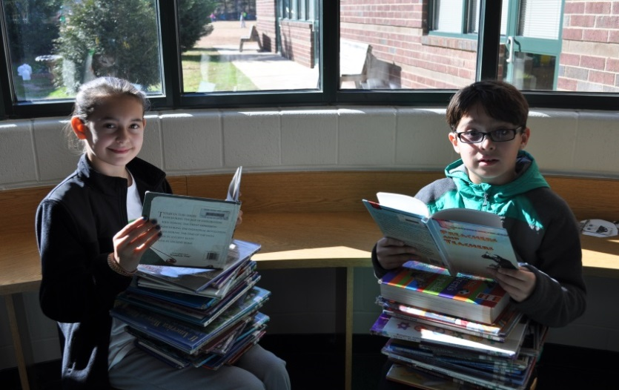

# Six Flags Read to Succeed

Do you like Six Flags? Do you like to read? Then become a member of the Six Flags Read to Succeed Club! To become a member, you need to read for fun for a total of six hours. If you read 30 minutes a day, you will reach 360 minutes in just 12 days! You can read books, magazines, comic books, or newspapers. Remember that reading for homework, a class assignment/project, or any reading for a grade doesn’t count. The window for reading is Tuesday, January 20, 2015 to Friday, February 20, 2015. Forms turned in after February 20th will not be accepted. See Mrs. Barnes if you need a new form.

Congratulations to these students for reading one million words this year!

Visit our Media Center Webpage at

[www.bufordacademymediacenter.weebly.com](http://www.bufordacademymediacenter.weebly.com)

Students are really enjoying the new reading program, Scholastic Reading Counts. See the site below for more information.  
<http://src.scholastic.com>  
  
Georgia Milestones Practice Tests  
<http://learnoas.ctb.com/GA/>

