Media Center Newsletter

### Buford City Schools

**Buford, GA**

May 15th, 2015

Brittany Barnes

Media Specialist

Buford Academy

banner with apples and crayons

# Upcoming Events

# Million Word Club Members

May 1st - August 16th: Gwinnett County Public Library Summer Reading Program  
May 18th: SRC Rewards Party for Top 3 Readers in each homeroom and Million Word Club Members  
1:30-2:10 pm for 4th/5th grade  
2:15-2:55 pm for 2nd/3rd grade  
May 18th: Buford-Sugar Hill Branch Library Event, 4:30-7:00 pm  
May 22nd: Last Day of School

34. Tayte Taliaferro- 3rd grade 35. Alex Aguirre- 4th grade  
36. Blaise Wylie- 5th grade   
37. Edna Umukodo- 4th grade  
38. Micah Creech- 4th grade  
39. Brent Warren- 5th grade  
40. Julia Travis- 3rd grade  
41. Marigrace Crossett- 5th grade  
42. Gracey Kemp- 5th grade  
43. Sophie Brewer- 5th grade  
44. Jason Mendez-Baza- 5th grade  
45. Colin McCollough- 5th grade  
46. Izzy Brewer- 5th grade  
47. JT Warren- 5th grade  
48. Max Rischar- 5th grade  
49. Vincent Tarvin- 5th grade  
50. Stephen Cole- 5th grade  
51. Lillian English- 5th grade  
52. Brady Ross- 2nd grade  
53. Cole Rhule- 5th grade  
54. Ethan Choi- 3rd grade  
55. Joe Miller- 5th grade  
56. Aidan Clonts- 5th grade  
57. Preston Rickards- 2nd grade  
58. Hannah Davidson- 4th grade  
59. Isaac Kim- 4th grade  
60. Aiden Smith- 5th grade  
61. Katie Earl- 5th grade  
62. Alayna Williamson- 3rd grade  
63. Lily Davidson- 2nd grade  
64. Ashton Persall- 4th grade  
65. Madden Young- 3rd grade

1. Noah Johnson- 4th grade  
2. Abe Gonzalez- 5th grade  
3. Conner Johnston- 5th grade  
4. Andrew Mixon- 4th grade  
5. Sean Bailey- 5th grade  
6. Juan Borrego- 5th grade  
7. Reece Pomerantz- 4th grade  
8. Trey Kazienko- 5th grade  
9. Nicolas Keller- 4th grade  
10. Marco Borrego- 5th grade  
11. Maya Joshi- 4th grade  
12. Dillon Dombroski- 4th grade  
13. Emily Garcia- 3rd grade  
14. Harrison Cleveland- 5th grade  
15. Parker Fulginiti- 5th grade   
16. Ruben Chavez- 5th grade  
17. Macy Dale- 5th grade   
18. Jackson Bare- 4th grade  
19. Skylar Gindlesperger- 3rd grade   
20. Paul Kwak- 5th grade   
21. Amelia Barnard- 5th grade   
22. Daygan Wasson- 4th grade   
23. Jackson Perry- 5th grade   
24. Laney Berkemeier- 5th grade   
25. Ian McManners- 5th grade   
26. Thomas Chambers- 4th grade   
27. Thomas DeGoey- 5th grade  
28. Brice Reynolds- 4th grade   
29. Ryan Davidson- 5th grade  
30. Isabell Russo- 3rd grade   
31. RJ Mazurek- 5th grade   
32. Ben Irwin- 4th grade  
33. Aubrey Pettit- 5th grade

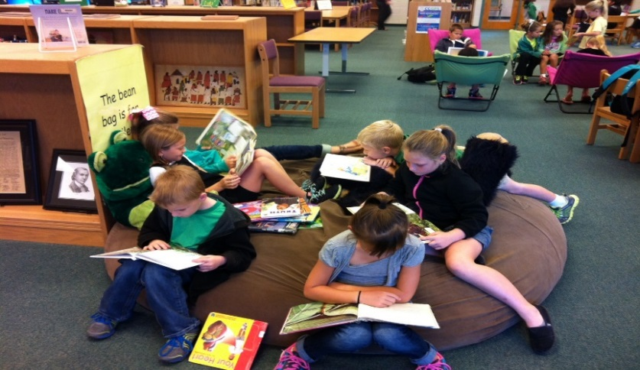

# Summer Reading

Want to find a way to keep your kids reading all summer long? Well, good news! The Gwinnett County Public Library has an amazing summer reading program. We also have summer reading lists available. For information on both of these awesome summer reading tips, please visit [www.bufordacademymediacenter.weebly.com](http://www.bufordacademymediacenter.weebly.com) under the Summer Reading tab! You can always email Mrs. Barnes at [Brittany.Barnes@bufordcityschools.org](mailto:Brittany.Barnes@bufordcityschools.org) for more information!



Congratulations to these students for reading one million words this year!